S20230010225 DBMS Lab 4

Q1a

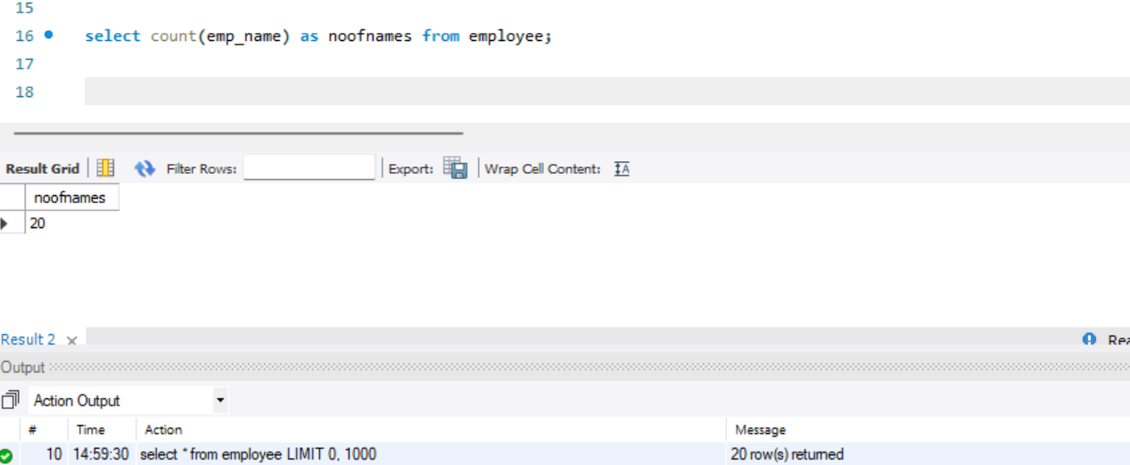

Q1b

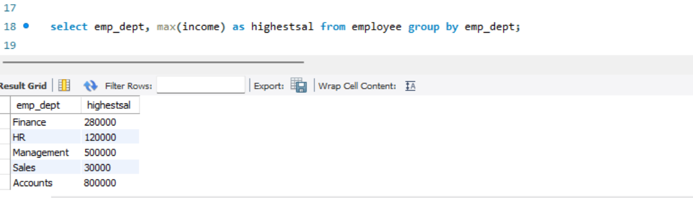

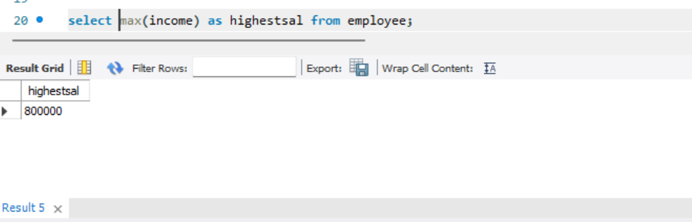

Q1c

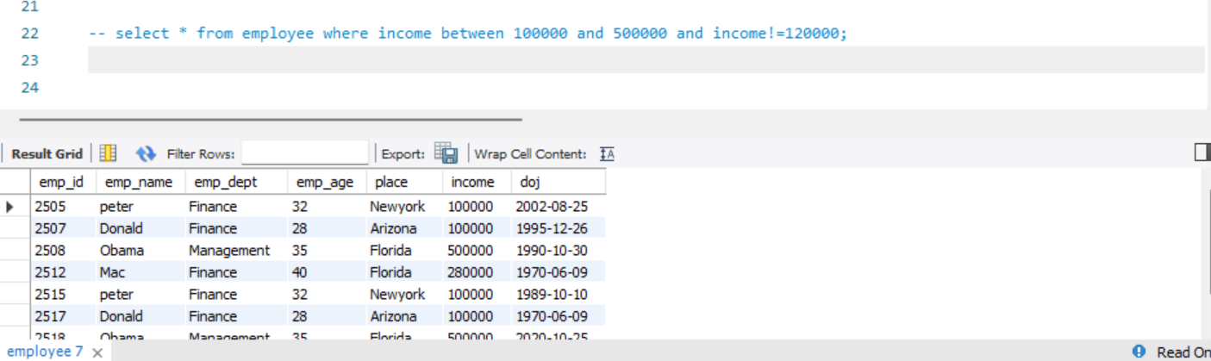

Q1d

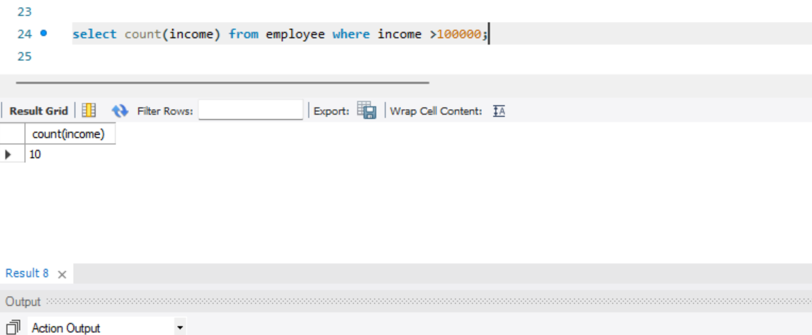

Q1e

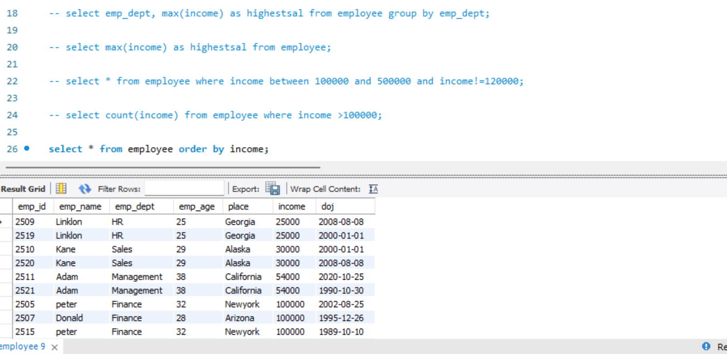

Q1f

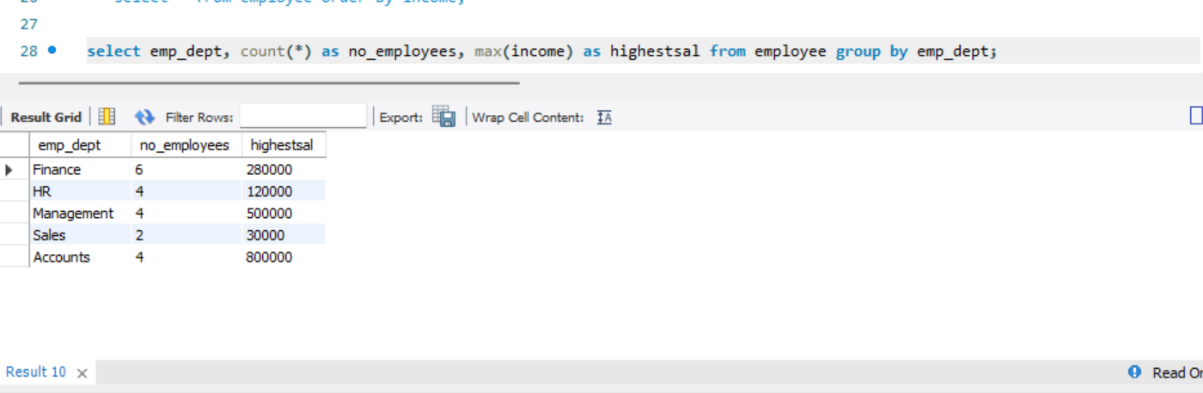

Q1 7

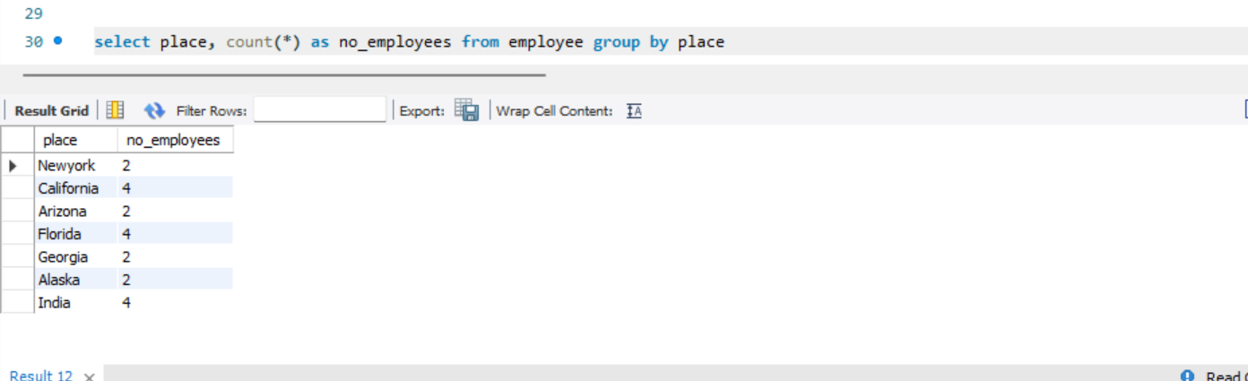

Q1 8

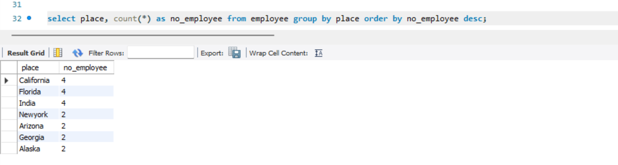

Q1 9

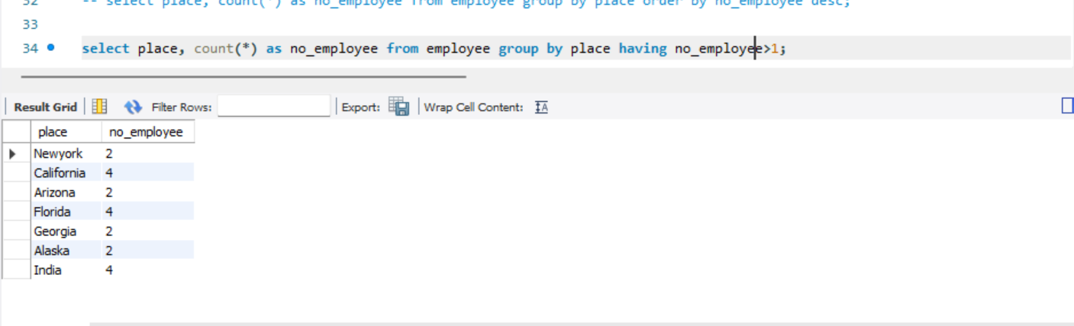

Q1 10

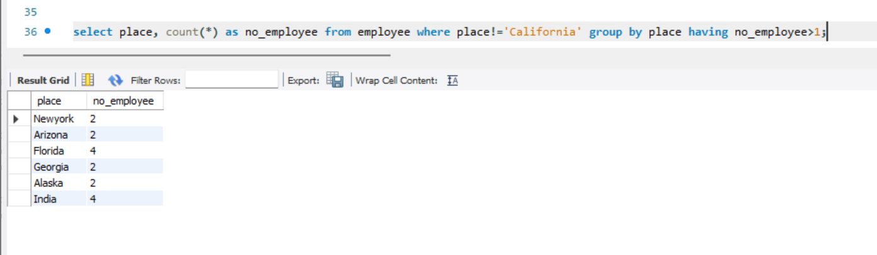

Q2 importing data from csv, creatinfg tables

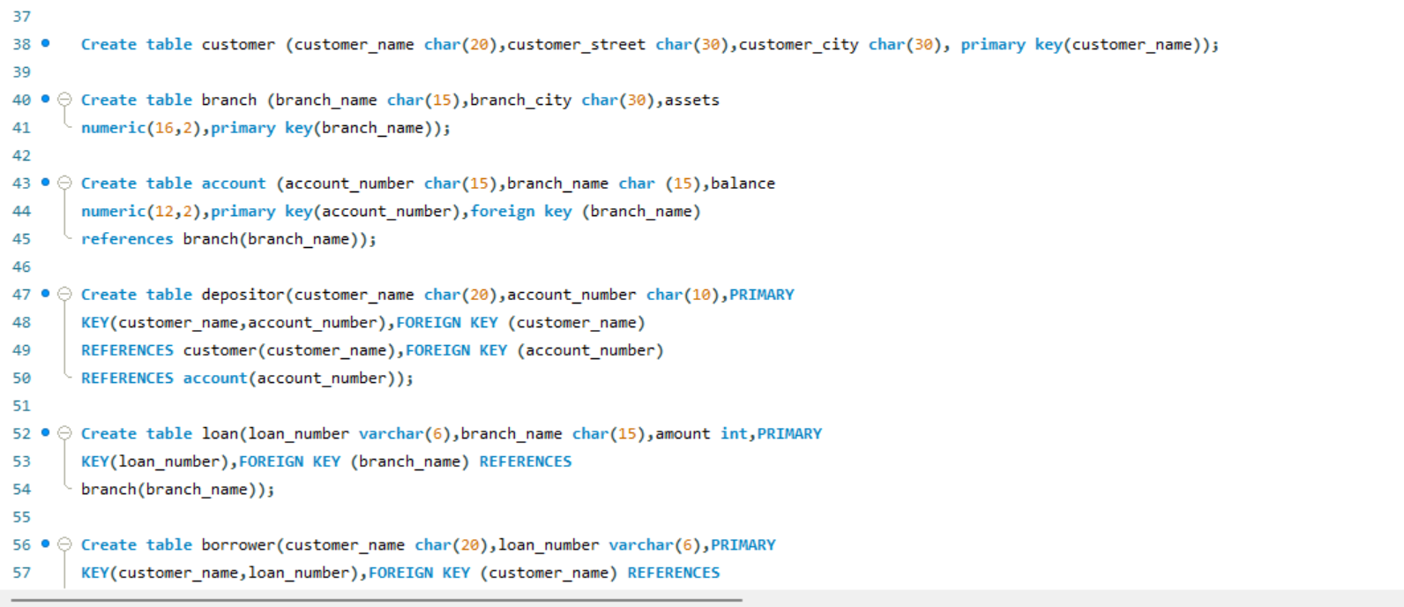

Q2 2 with renaming

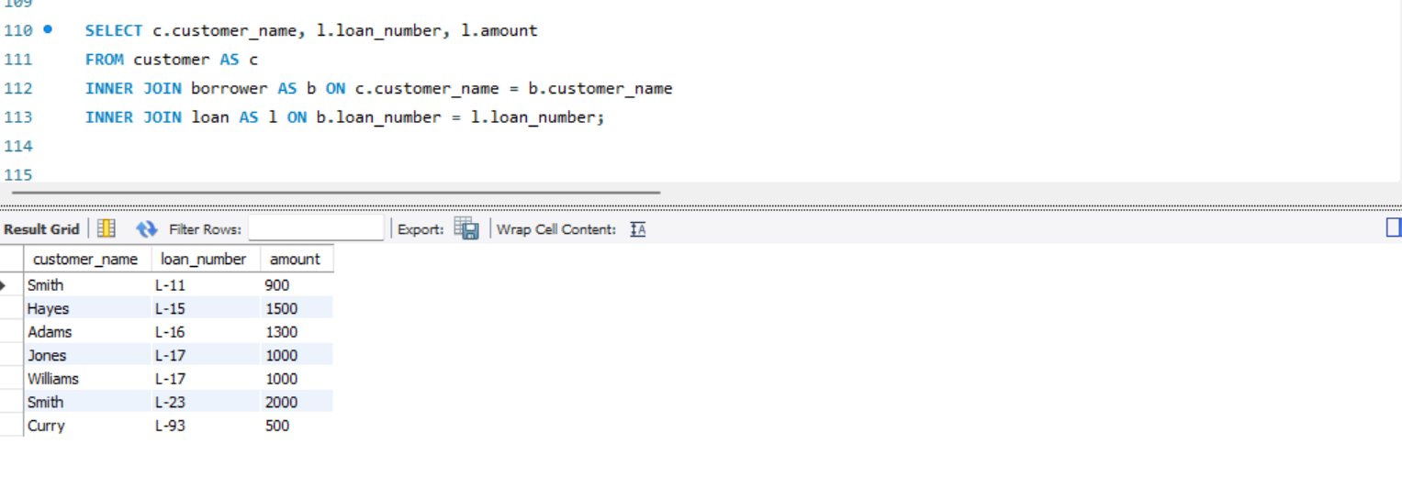

Q2 2 without renaming

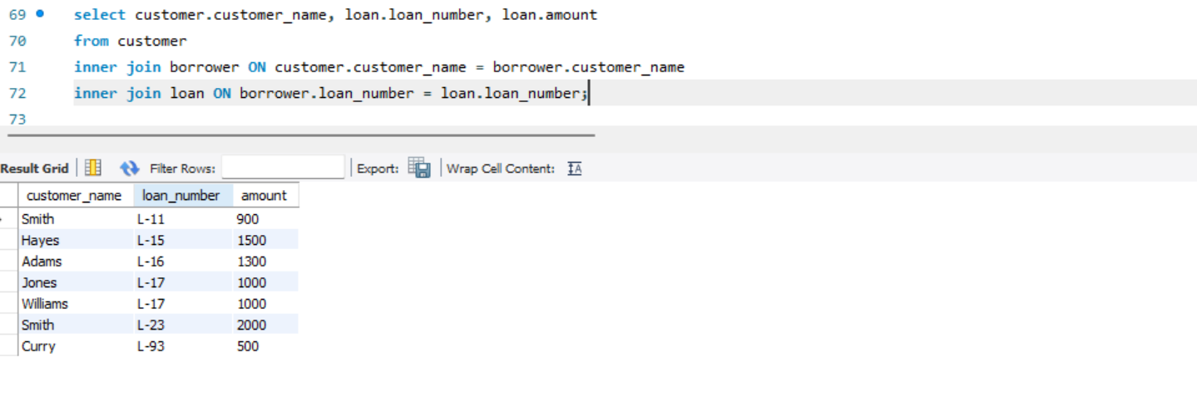

Q2 3

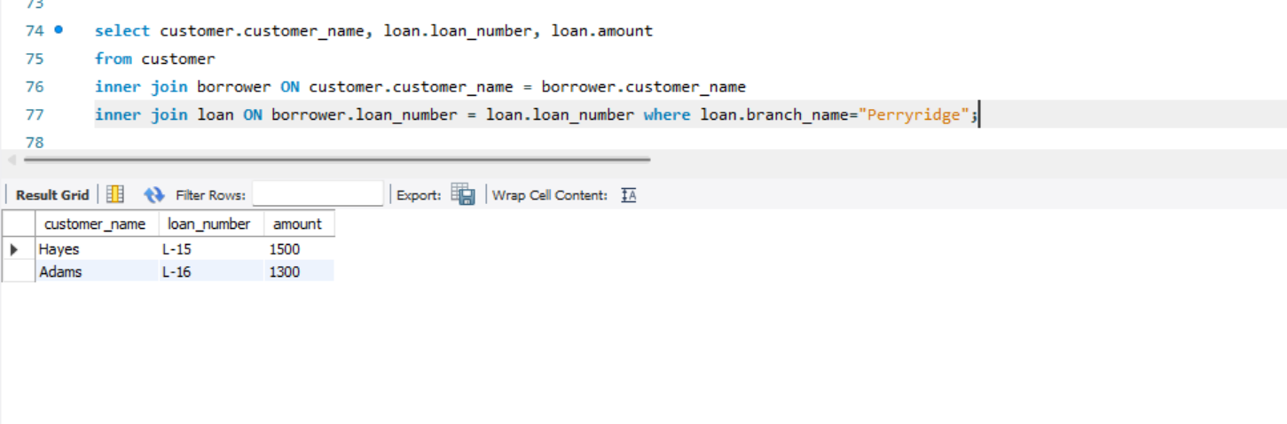

Q2 4

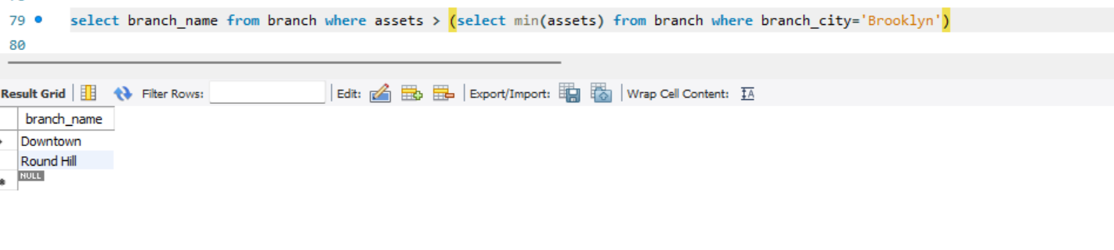

Q2 5

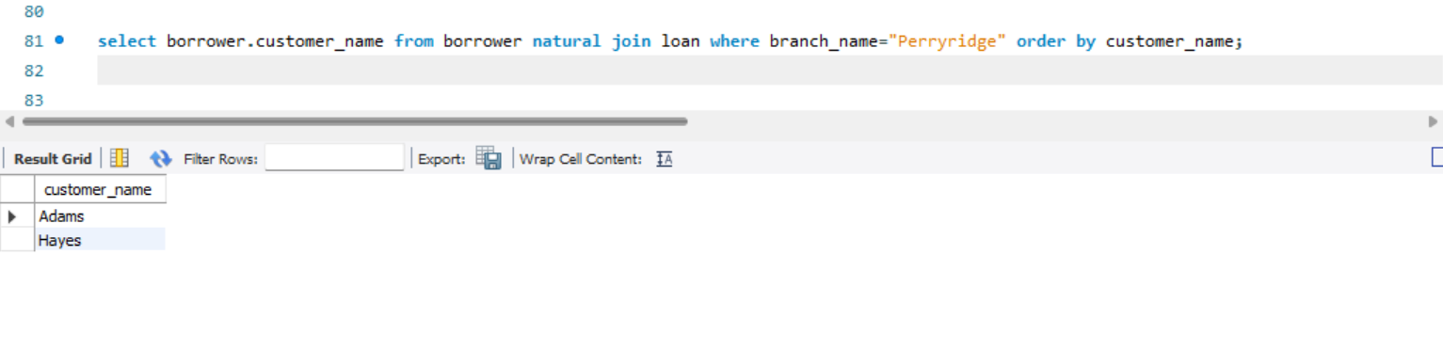

Q2 6

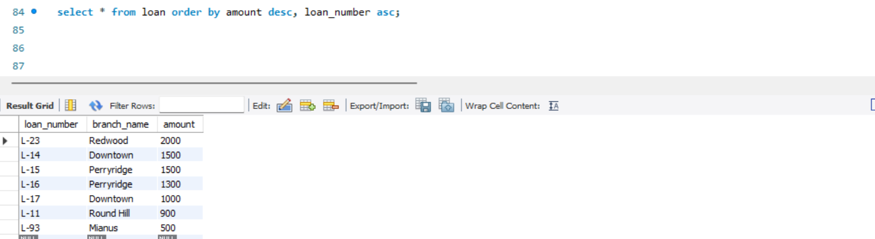

Q2 7

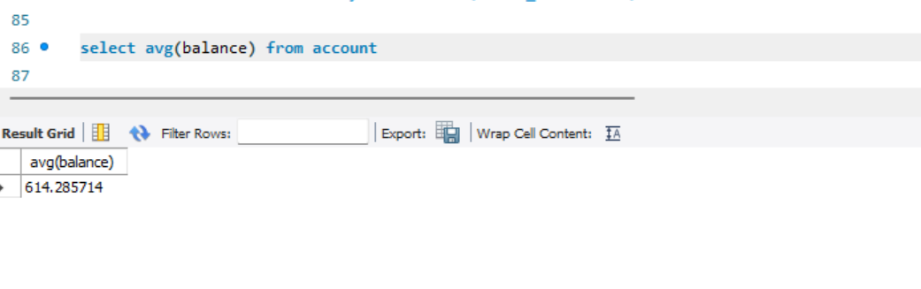

Q2 8

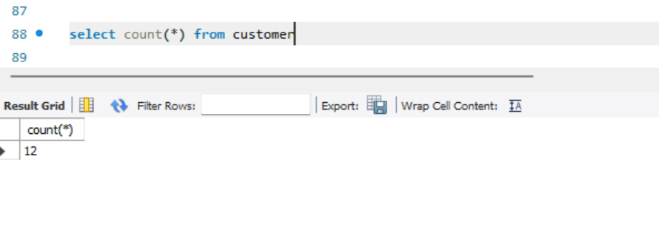

Q2 9

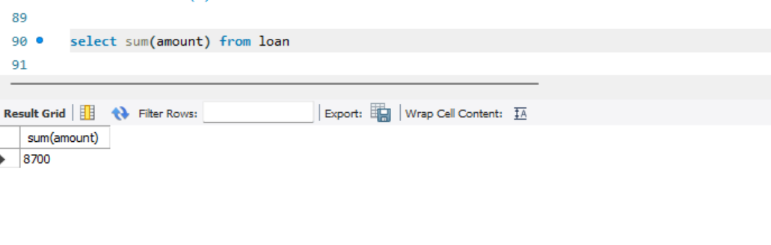

Q2 10

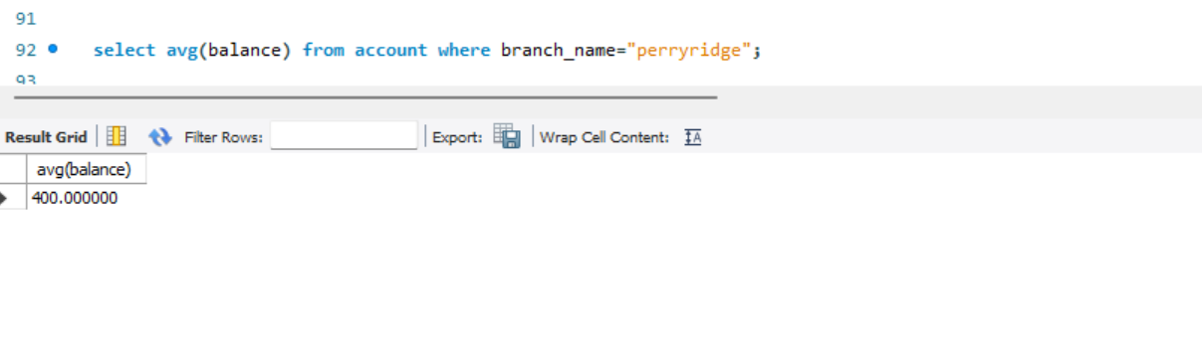

Q2 11

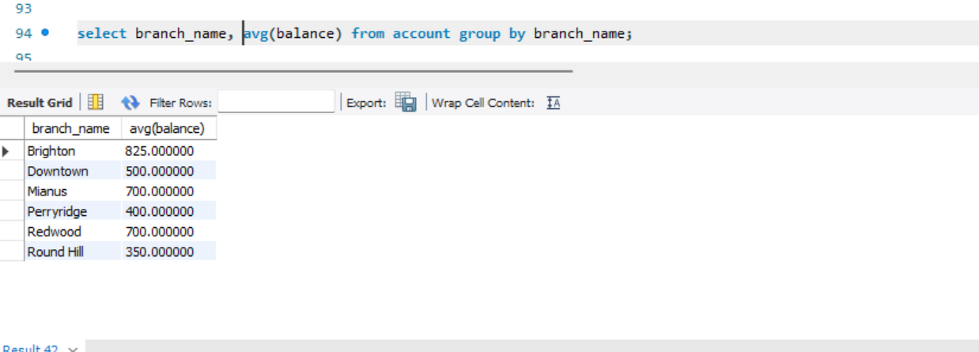

Q2 12

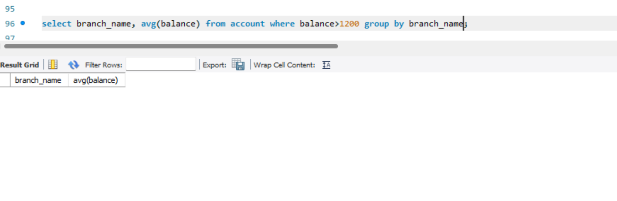

Q2 13

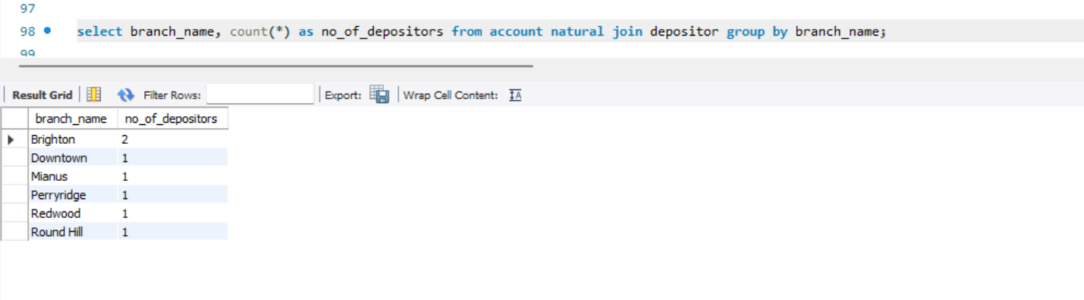

Q2 14

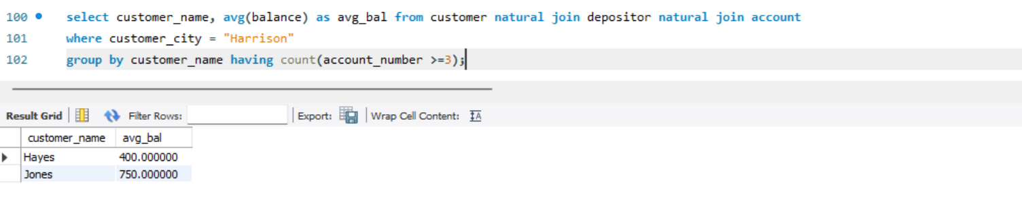

SQL CODE:

-- create database S20230010225_Lab4

-- create table employee(

-- emp_id int,

-- emp_name varchar(20),

-- emp_dept varchar(20),

-- emp_age int,

-- place varchar(20),

-- income int,

-- doj date);

--

-- alter table employee auto_increment=2505;

-- select * from employee

-- select count(emp_name) as noofnames from employee;

-- select emp_dept, max(income) as highestsal from employee group by emp_dept;

-- select max(income) as highestsal from employee;

-- select * from employee where income between 100000 and 500000 and income!=120000;

-- select count(income) from employee where income >100000;

-- select * from employee order by income;

-- select emp_dept, count(*) as no_employees, max(income) as highestsal from employee group by emp_dept;

-- select place, count(*) as no_employees from employee group by place

-- select place, count(*) as no_employee from employee group by place order by no_employee desc;

-- select place, count(*) as no_employee from employee group by place having no_employee>1;

-- select place, count(*) as no_employee from employee where place!='California' group by place having no_employee>1;

-- create table customer (customer_name char(20),customer_street char(30),customer_city

-- char(30),PRIMARY KEY(customer_name));

-- Create table branch (branch_name char(15),branch_city char(30),assets

-- numeric(16,2),PRIMARY KEY(branch_name));

-- Create table account (account_number char(15),branch_name char (15),balance

-- numeric(12,2),PRIMARY KEY(account_number),FOREIGN KEY (branch_name)

-- REFERENCES branch(branch_name));

-- Create table depositor(customer_name char(20),account_number char(10),PRIMARY

-- KEY(customer_name,account_number),FOREIGN KEY (customer_name)

-- REFERENCES customer(customer_name),FOREIGN KEY (account_number)

-- REFERENCES account(account_number));

-- Create table loan(loan_number varchar(6),branch_name char(15),amount int,PRIMARY

-- KEY(loan_number),FOREIGN KEY (branch_name) REFERENCES

-- branch(branch_name));

-- Create table borrower(customer_name char(20),loan_number varchar(6),PRIMARY

-- KEY(customer_name,loan_number),FOREIGN KEY (customer_name) REFERENCES

-- customer(customer_name),FOREIGN KEY (loan_number) REFERENCES

-- loan(loan_number));

-- SELECT c.customer_name, l.loan_number, l.amount

-- FROM customer AS c

-- INNER JOIN borrower AS b ON c.customer_name = b.customer_name

-- INNER JOIN loan AS l ON b.loan_number = l.loan_number;

-- select customer.customer_name, loan.loan_number, loan.amount

-- from customer

-- inner join borrower ON customer.customer_name = borrower.customer_name

-- inner join loan ON borrower.loan_number = loan.loan_number;

-- select customer.customer_name, loan.loan_number, loan.amount

-- from customer

-- inner join borrower ON customer.customer_name = borrower.customer_name

-- inner join loan ON borrower.loan_number = loan.loan_number where loan.branch_name="Perryridge";

-- select branch_name from branch where assets > (select min(assets) from branch where branch_city='Brooklyn')

-- select borrower.customer_name from borrower natural join loan where branch_name="Perryridge" order by customer_name;

-- select * from loan order by amount desc, loan_number asc;

-- select avg(balance) from account

-- select count(*) from customer

-- select sum(amount) from loan

-- select avg(balance) from account where branch_name="perryridge";

-- select branch_name, avg(balance) from account group by branch_name;

-- select branch_name, avg(balance) from account where balance>1200 group by branch_name;

-- select branch_name, count(*) as no_of_depositors from account natural join depositor group by branch_name;

-- select customer_name, avg(balance) as avg_bal from customer natural join depositor natural join account

-- where customer_city = "Harrison"

-- group by customer_name having count(account_number >=3);